Grant proposal template:
Usually funding agencies have very specific formats for grant applications. However, the following headings are usually used in the following order:
- Cover letter: This would include the title of the research project, a brief description of the project, the names of the principal investigator(s)/ collaborators, the institutional affiliation of the applicants (the department and university), amount of funding requested along with signatures of university personnel authorizing the proposal (if applicable).
- One-page concept note: This might provide readers with their first impression of the project and also, readers might use this concept note to glance through to remind them of the project before taking the final decision. Hence, this is one of the important parts of the proposal. This should address research significance (Why this research?), innovation (Originality/ novelty), approach (study design and methods appropriate?), investigators (Why you?), and environment (Why your institution?) in a brief way.
- Introduction: Should state ‘what the problem is’, ‘why is it a public health problem?’, ‘what is currently known and not known- gap in knowledge’. This should be supported by an appropriate literature search and should be evidence-based.
- Project narrative: should include objectives, methods, procedures, outcomes or deliverables, evaluation, and dissemination. A timeline can be added to this section. (Fig 1)
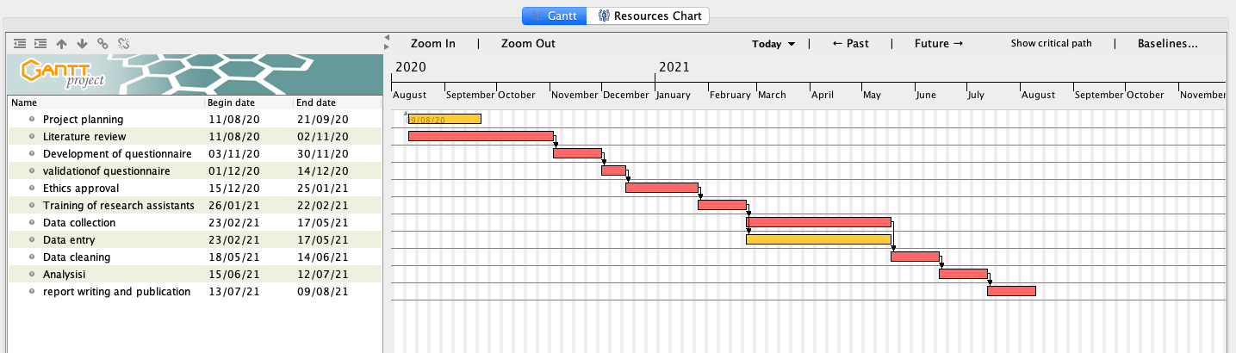
Figure 1: Example of a Gantt chart with various activities and proposed timelines
- Personnel: Explain the need of personnel for the project, the amount of time needed to be spent on the project, their field of expertise/skill set required etc. The Curriculum Vitae can be added as an annexure to the proposal. Explain how would you minimize expenses by appointing the required personnel only during a particular proposed work and how you would phase out personnel not relevant to the later phases of the project.
- Budget and budget justification:
Sample Table1: Example of a budget plan.
Expense categories | Details | 2020 | 2021 | 2022 | 2023 | 2024
Ring-fenced fund | Salaries of research support staff:  Qualification  Time spent on the project
 | Host institution overheads
Transferable funds | Equipment  Model name, company details  (maintenance charges to be included)
 | Travel and transportation
 | Consumables- details
 | Stationaries and miscellaneous expenses
Total expenses per year
The total budget of the project
The budget narrative should contain detailed justification for each item listed in the budget table.

